CIM Bulletin Author Information

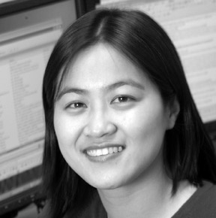
Oy Leuangthong, PhD, P.Eng.
Dr. Leuangthong is an Assistant Professor in the School of Mining and Petroleum Engineering at the University of Alberta. She is an Alberta Ingenuity Researcher, and teaches and conducts research into improved characterization of natural resources using geostatistics.

Emmanuel Schnetzler, M.S., P.Eng.
Mr. Schnetzler is a consultant in geostatistics and a co-founder of Statios LLC. He is involved in the development of software solutions for modeling mineral deposits. He conducts studies and provides courses for professionals in the use of geostatistical methods for characterization of natural resources.

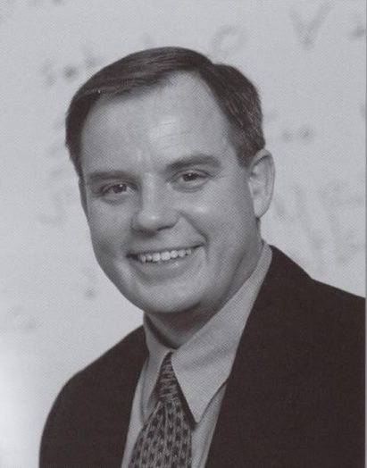
Clayton V. Deutsch, PhD, P.Eng.
Dr. Deutsch holds the Canada Research Chair in Natural Resources Uncertainty Characterization and the Alberta Chamber of Resources Industry Chair in Mining Engineering. He is Director of the School of Mining and Petroleum Engineering at the University of Alberta. He teaches and conducts research into better ways to model heterogeneity and uncertainty in mineral deposits.

